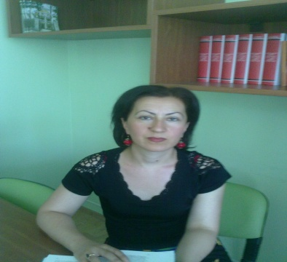

Name, Surname Lia Chalatashvili
Date of birth 30. 07. 1971
Contact coordinates 551 28 77 25 ; 27 59 83
Marital status: Husband and two children

Education 1988-1998 year. Telavi II school. 1990-1995 year. Iv. Javakhishvili State
University, Faculty of Economics, Macroeconomics Specialty
Qualification Economist
Work experience 2003-2006 years Telavi Branch of Agrarian University, Chair of Economics . Department of Agro-Economics, The laborer.
2006 - 2012 Telavi State University, Faculty of Social Sciences, Business and Law, Chair of Economics, The laborer.
2011-2014 Assistant of the International Project "BOMUP" funded by Volkswagen Foundation
From 2012 till present Telavi I. Gogebashvili State University Specialist of Social Sciences, Business and Law Faculty
Learning course: 2011-2012 - IBSU and Telavi I. Successful participant of Turkish language courses at Gogebashvili State University;
2014-15 - IBSU and Telavi I. Successful participant of Turkish language courses at Gogebashvili State University;
Trainings: Business-Training (Management, Marketing, Advertising, Public Relations, Accounting Accounting) 2011 in the framework of the project "Entrepreneur Support Center" (CIDF) by business center "Kakheti" March-April, # 38

The course of training of Georgian Red Cross Organization on "Social Needs Participatory Appraisal Methodologies" 30 July-1 August, 2013
Georgian National Center for Quality Enhancement, Compulsory General Module of Entrepreneurship, Tbilisi 2015, which is implemented within the framework of Vocational Qualifications Development Program.
Training for teachers organized by Tempus Project SUTOMA "Practical Placement Module 5", 2-3 July, 2015, TESAU.
Languages: GEORGIAN (native)
Russian (on average).
English (on average).
Turkish (on average)
Technical skills of computer
WORD, ECXELL,
ACCESS Software, Internet.

Other Skills Organizational Activities, Teamwork , Work, sociable.

Other interests Question, Travel, Art.

